**Swiggy Restaurant Data Analysis Report**

**Project Title: Restaurant Analysis of Swiggy**

**Objective**

The primary aim of this project is to analyze and visualize restaurant data from Swiggy to gain meaningful insights and make informed business decisions. This analysis focuses on understanding customer preferences, operational efficiency, and market positioning while utilizing Power BI for visualization and dashboard creation.

**Dataset Details**

* Source: Provided CSV file with restaurant data.
* Variables:
  + ID: Unique identifier for each restaurant.
  + Area: Neighbourhood within the city where the restaurant is located.
  + City: The city of operation.
  + Restaurant: Name of the restaurant.
  + Price: Average cost of dining at the restaurant.
  + Avg Ratings: Average rating given by customers.
  + Total Ratings: Total number of ratings received.
  + Food Type: Cuisine or food category served.
  + Address: Full address of the restaurant.
  + Delivery Time: Average time taken to deliver orders.

**Analysis Approach**

1. **Data Cleaning and Preprocessing**:
   * Handled missing values, corrected data types, and removed duplicates.
   * Ensured consistency in the dataset for accurate analysis.
   * Split food type column using split column -> Delimiter.
2. **Data Transformation**:
   * Created additional columns - Rating categories (Excellent, Average and Poor)

if [Average Ratings] < 3 then "Poor"

else if [Average Ratings] >= 3 and [Average Ratings] < 4.5 then "Average"

else "Excellent"

and Price ranges (High, Medium and Low).

"Price Range", each if [Price] <= 200 then "Low"

else if [Price] > 200 and [Price] <= 500 then "Medium"

else if [Price] > 500 then "High"

* + Food Type into Attribute and values.

1. **Visualization and Dashboard Creation**:
   * Designed and developed interactive visualizations in Power BI.
   * Integrated visualizations into a cohesive dashboard for comprehensive insight extraction.

**Key Analysis Tasks and Visualizations**

**Task 1: Top 10 Areas with Most Restaurants**

* Visualization: Bar Chart
  + X-Axis: Number of Restaurants (Count of ID)
  + Y-Axis: Area

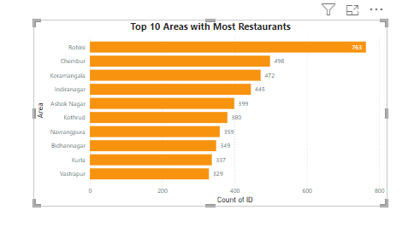

* Insights: The bar chart highlights areas with the highest concentration of restaurants. These are potential hotspots where competition is intense or demand is high.

**Task 2: Most Popular Food Types in Each City**

* **Visualization**: Tree Map
  + **Category**: City
  + **Details**: Food Types ( Filtered using Top 5 Food Types)
  + **Values**: Count of ID

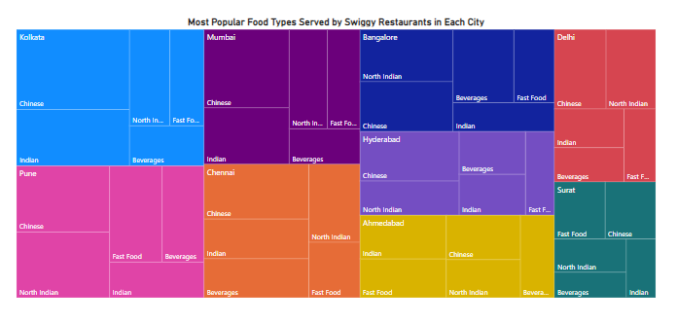

* **Insights**: Popular food types vary by city, indicating regional preferences. This data can guide menu diversification strategies.

**Task 3: Top Rated Swiggy Restaurants (Percentage)**

* **Visualization**: Donut Chart
  + **Legend**: Rating Category
  + **Values**: Count of ID
  + **Details**: Restaurant

RatingCategory = IF([Avg Ratings] >= 4.5, "Top Rated", "Others")

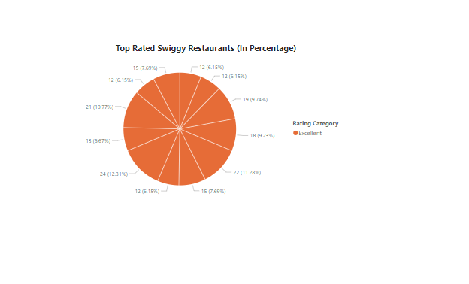

* **Insights**: Shows the proportion of restaurants with average ratings above 4.5. Identifying these high performers can help benchmark quality standards.

**Task 4: Correlation Analysis**

* **Scatter Plot 1**: Price vs. Average Ratings
  + **X-Axis**: Price
  + **Y-Axis**: Average Ratings
  + **Size**: Total Ratings
  + **Legend**: City

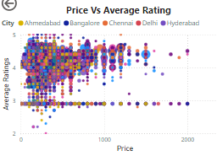

* **Scatter Plot 2**: Delivery Time vs. Average Ratings
  + **X-Axis**: Delivery Time
  + **Y-Axis**: Average Ratings

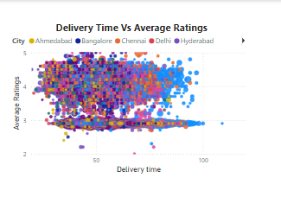

* **Insights**:
  + **Price and Ratings**: No strong correlation observed, suggesting price does not significantly influence customer satisfaction.
  + **Delivery Time and Ratings**: Potential trend showing that longer delivery times might slightly reduce ratings, indicating an opportunity to optimize logistics.

**Task 5: Correlation Between Price and Average Ratings**

* **Scatter Plot Setup**: Same as above for an in-depth examination.
  + **X-Axis**: Price
  + **Y-Axis**: Average Ratings
  + **Size**: Total Ratings
  + **Legend**: City



* **Insights**: Outliers in this plot could highlight high-cost restaurants that underperform or low-cost eateries that excel.

**Task 6: City-Wise Restaurant Count**

* **Visualization**: Map Visualization
  + **Location**: City
  + **Values**: Number of Restaurants

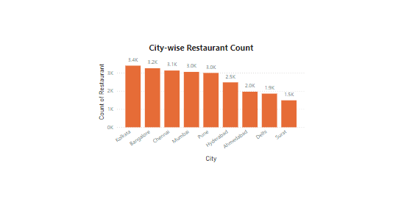

* **Insights**: Visual representation of how restaurants are distributed across different cities. Cities with high restaurant counts may signify robust food service markets.

**Task 7: Price Analysis**

**Visualization**: Bar Plot

* **X-Axis**: Restaurant (or count of restaurants)
* **Y-Axis**: Price Range
* **Legend**: Restaurant

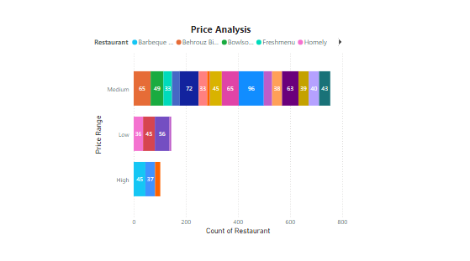

**Insights:**

**1.Identify Popular Price Ranges:**

* Determine which price categories have the highest concentration of restaurants. This could indicate customer affordability preferences or restaurant market strategies. - Medium

**2.Distribution Trends:**

* If most restaurants fall within a medium price range, it suggests a market focus on affordability and accessibility.
* Fewer restaurants in the premium category may indicate a niche market that could be tapped into.

**3.Potential Business Strategy:**

* If the premium segment has fewer restaurants but consistent high ratings, it may be a lucrative area for new business ventures.
* Conversely, if the lower-priced categories are saturated, businesses may need to differentiate themselves through quality or unique offerings.

**Task 8: Delivery Time Analysis**

* **Visualization**: Line Plot
* **X-Axis:** Choose Area or City (if you want to analyze delivery times based on different areas or cities). You can also use a Date field if you have time-based data.
* **Y-Axis:** Delivery Time (Ensure this field is set to an appropriate aggregation like *Average* to show the trend in average delivery times).
* **Legend:** Use City or Area if you want to compare delivery times across different regions.

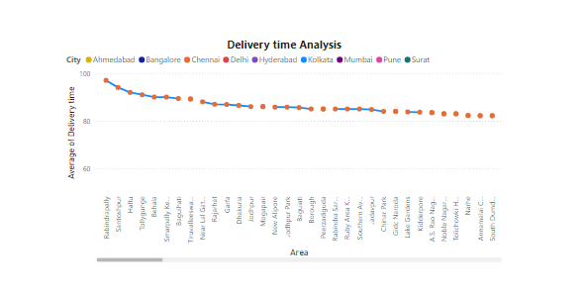

**Insights:** For areas with consistently high delivery times, consider strategic changes like optimizing delivery routes, increasing the number of delivery personnel, or establishing more localized distribution hubs. Areas or cities with lower average delivery times could indicate efficient operations, whereas higher times may require logistical improvements.

**Task 9: Cuisine Analysis**

* **Visualization: Tree Map**
  + **Categories: Food Type**
  + **Values: Number of Restaurants**

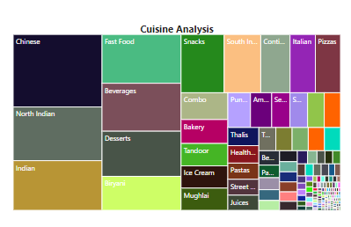

* **Insights:** Visualizes the diversity of cuisines offered, highlighting popular and less common food options.

**Task 10: Area-Wise Restaurant Analysis**

* **Visualization**: Tree Map
  + **Category**: Area
  + **Values**: Count of Restaurants

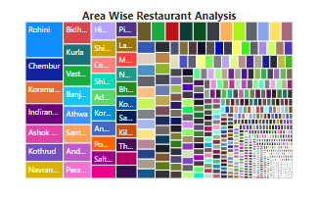

* **Insights**: Identifies areas with restaurant clusters and potential gaps in the market.

**Task 11: Customer Feedback Analysis**

* **Visualization**: Bar Chart
  + **X-Axis**: Rating Category
  + **Y-Axis**: Total Ratings

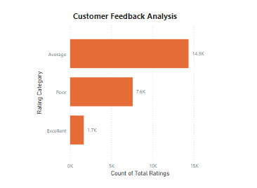

* **Insights**: Analyzes customer sentiment and overall satisfaction trends.

**Task 12: Geographical Mapping**

* **Visualization**: Tree Map
  + **Category**: Address or Area
  + **Values**: Average Ratings

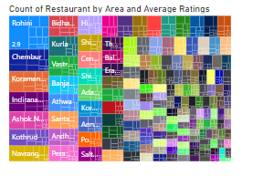

* **Insights**: Maps restaurant locations and their ratings, useful for understanding regional performance.

**Task 14: Business Recommendations**

1. **Operational Efficiency**: Focus on reducing delivery times to improve customer satisfaction, especially in areas with lower ratings.
2. **Pricing Strategy**: Consider benchmarking prices for high-performing restaurants to understand what drives customer value.
3. **Customer Engagement**: Analyze popular restaurants with high engagement but lower ratings to identify improvement areas.
4. **Menu Diversification**: Use city-wise food type preferences to tailor menus to regional tastes, enhancing market positioning.
5. **Expansion Opportunities**: Invest in areas with fewer restaurants or lower competition to capture unmet demand.

**Dashboard:**

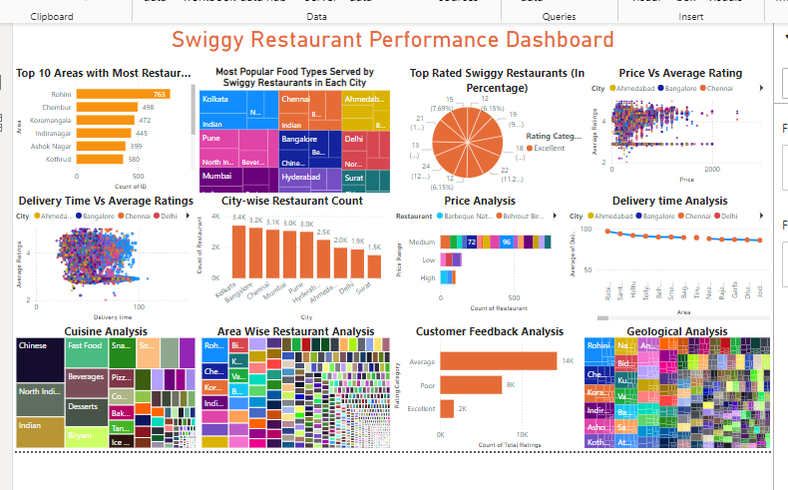

Power BI Files

Thank you.